Scientific Computing

MATH6183001

**NUMERICAL DIFFERENTIATION**

There are several methods:

1. First Central Difference Approximation (order O(h2))

2. First Forward Difference Approximation (order O(h))

3. First Backward Difference Approximation (order O(h))

4. Second Forward Difference Approximation (order O(h2))

5. Second Backward Difference Approximation (order O(h2))

All of these can be used if the data points are located at even interval of x (evenly spaced).

**1. Central Difference Approximation, O(h2)**

From Taylor Series we have:

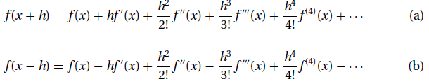

Subtracting (a) – (b), and adding (a) + (b), we have:

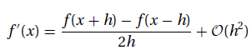



Summary:

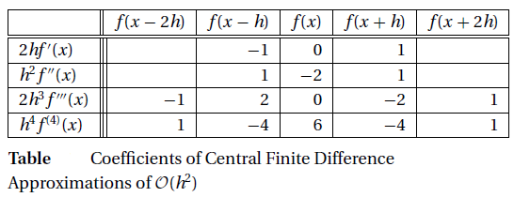

**2. First Forward Difference Approximation (O(h))**

Summary:

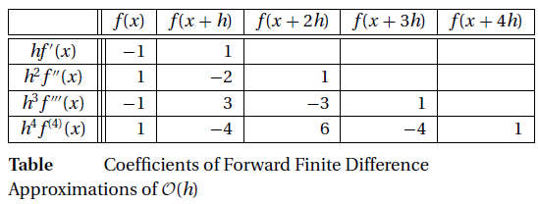

**3. First Backward Difference Approximation (O(h))**

Summary:

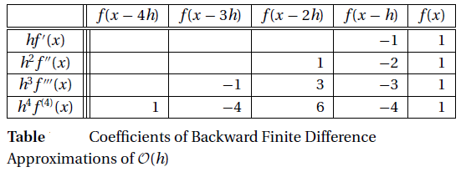

**4. Second Forward Difference Approximation (O(h2))**

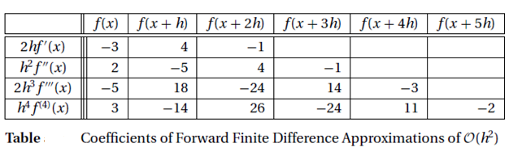

**5. Second Backward Difference Approximation (O(h2))**

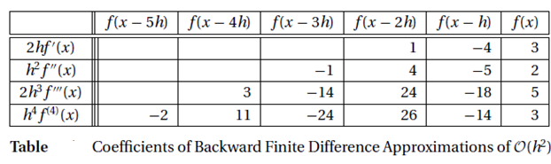

Example

|  |  |  |  |  |  |  |  |
| --- | --- | --- | --- | --- | --- | --- | --- |
| $$x$$ | -0.1 | 0 | 0.1 | 0.2 | 0.3 | 0.4 | 0.5 |
| $$f(x)$$ | -0.0998 | 0.0000 | 0.0998 | 0.1987 | 0.2955 | 0.3894 | 0.4794 |

Compute f’(x) and f’’(x) at x = 0.2 (4 d.p) using:

a. First Central Difference Approximation (order O(h2))

b. First Forward Difference Approximation (order O(h))

c. First Backward Difference Approximation (order O(h))

d. Second Forward Difference Approximation (order O(h2))

e. Second Backward Difference Approximation (order O(h2))

Ans:

a. First Central Difference Approximation (order O(h2))

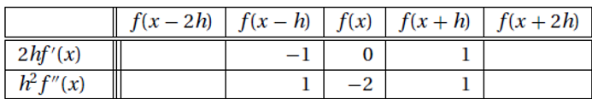

b. First Forward Difference Approximation (order O(h))

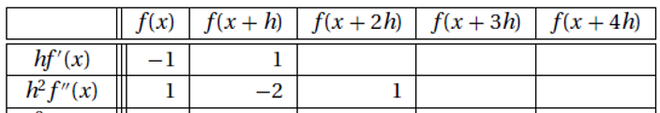

c. First Backward Difference Approximation (order O(h))

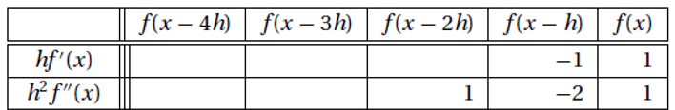

d. Second Forward Difference Approximation (order O(h2))

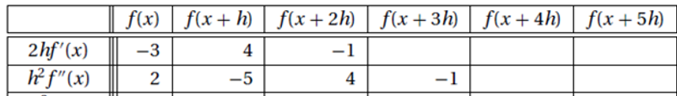

e. Second Backward Difference Approximation (order O(h2))

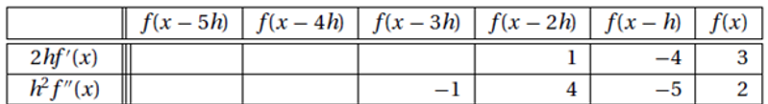

**Richardson Extrapolation**

For boosting the accuracy of numerical procedures.



Usually h2 = ½h1, so we have:



The value of p is a constant (usually p=2)

Example:

If y = f(x) = e–x then find:

a. exact value of y”(x) at x = 1 using analytical differentiation (6 d.p)

b. approximation of y”(1) using h1=0.64, central difference (6 d.p)

c. approximation of y”(1) using h2=0.32, central difference (6 d.p)

d. approximation of y”(1) using Richardson Extrapolation based on (b) and (c)

e. Conclude from a,b,c,d.

Ex: y = sin 2x.

a. Find y’(0) exactly

b. Find y’(0) by central difference O(h2) with h=0.2

c. Find y’(0) by central difference O(h2) with h=0.1

d. Use Richardson Extrapolation from (b) and (c)

e. What is your conclusion from (a), (b), (c) and (d)?

**Derivatives by Extrapolation**

This method is used if the data points are located at uneven interval of x. We can use quadratic interpolation



, with (n+1) data points and then evaluates the derivatives at the certain x.

Example:

|  |  |  |  |  |  |
| --- | --- | --- | --- | --- | --- |
| $$x$$ | 1.9 | 2.1 | 2.2 | 2.3 | 2.4 |
| $$f(x)$$ | -0.6119 | -0.8716 | -0.9516 | -0.9937 | -0.9962 |

Compute f’(2) and f’’(2) using polynomial interpolation over 3 nearest neighbor points (4 d.p). (hint: to solve the system of linear of equations we can use “numpy.linalg.solve”).

Ans: x=2 has 3 nearest neighbors 1.9, 2.1, and 2.2.

Example:

|  |  |  |  |  |  |
| --- | --- | --- | --- | --- | --- |
| $$x$$ | 0 | 0.1 | 0.2 | 0.3 | 0.4 |
| $$f(x)$$ | 1 | …… | 0.8187 | 0.7408 | 0.6703 |

Compute f’(0.1) and f’’(0.1) using polynomial interpolation over 3 nearest neighbor points (4 d.p).